Pipeline Creation

* 1. Copy Build and Deploy folder, .yml and nuke file from another project
  2. Open Solution
  3. Add Build and Deploy project in a solution, by Add existing project option.
  4. Similarly add .yml file for build and deploy
  5. Build.yml
     1. No need to change anything
  6. Deploy.yml
     1. Line#14 functionAppName : Change the Tenant ID from setup app. Keep "fax"
     2. Line#22 workingDirectory: Change working directory for Azure Repo name
  7. Build > .nuke
     1. Change solution name
  8. Build > FunctionBuild.cs
     1. Line#17: Change Project name
  9. Deploy > FunctionDeploy.cs
     1. Line#36: Change the repo name
     2. Line#38: Change TenantId
  10. Push changes
  11. Open Azure DevOps
  12. Go to pipelines

**CI Pipeline**

* 1. Click on "New Pipeline" button from top

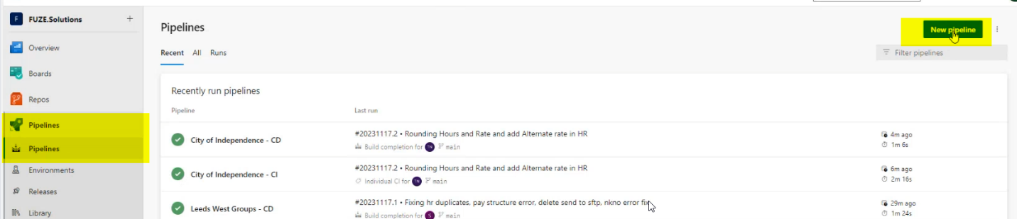

* 1. Click on "Azure Repos Git"

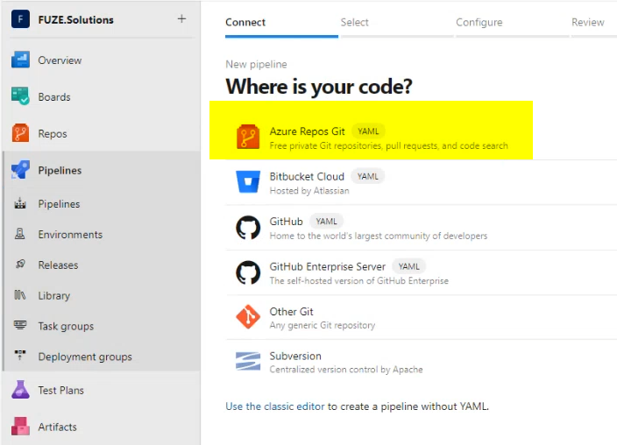

* 1. Click on "Azure Repos Git"
  2. Select your project's repo

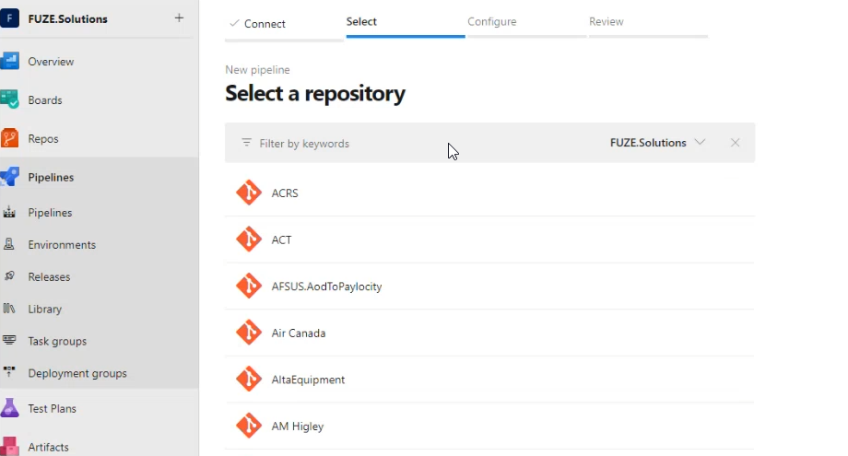

* 1. Select "Existing Azure Pipelines YMAL file

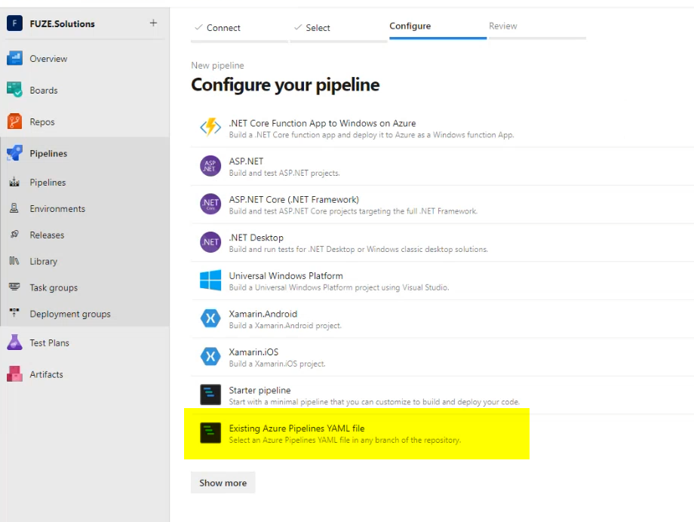

* 1. Select /build.yml file. Click on Continue.

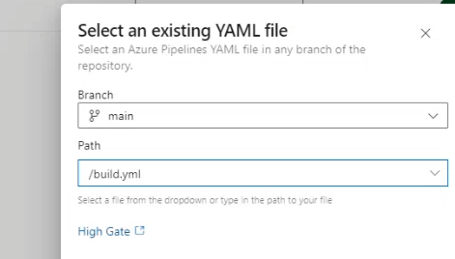

* 1. Click on dropdown icon with Run and click on Save.

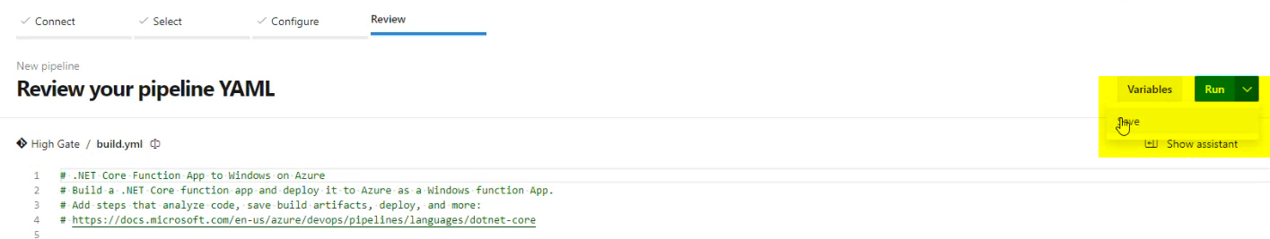

* 1. Once it is saved, below screen will appear.

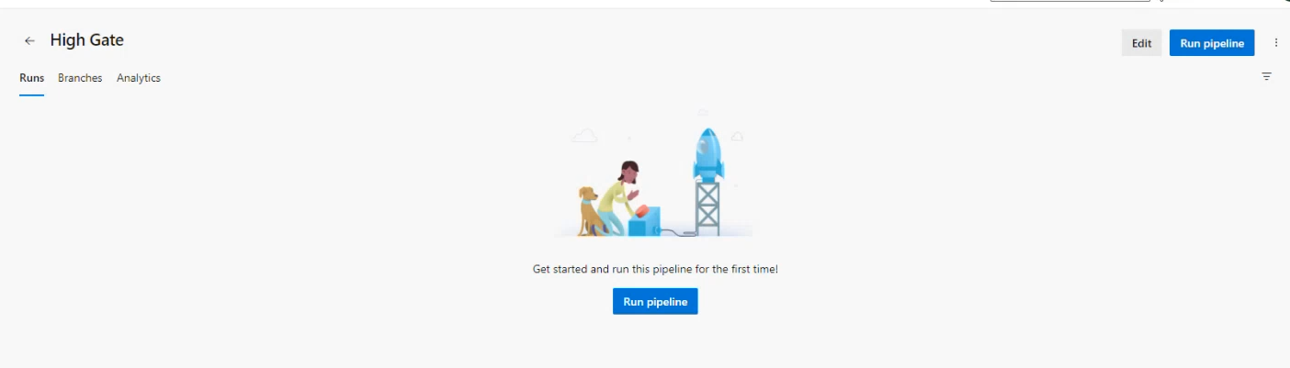

* 1. Click on "Edit" from top
  2. Click on a three dot icon > Triggers

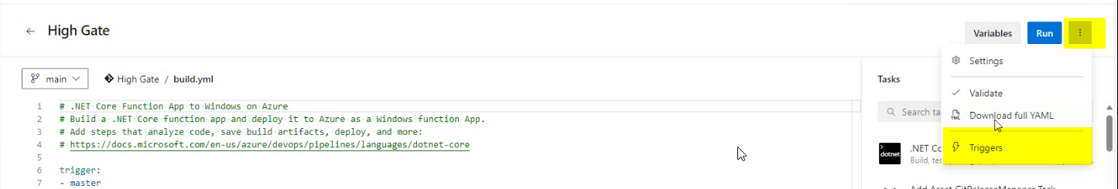

* 1. It opens the screens as below

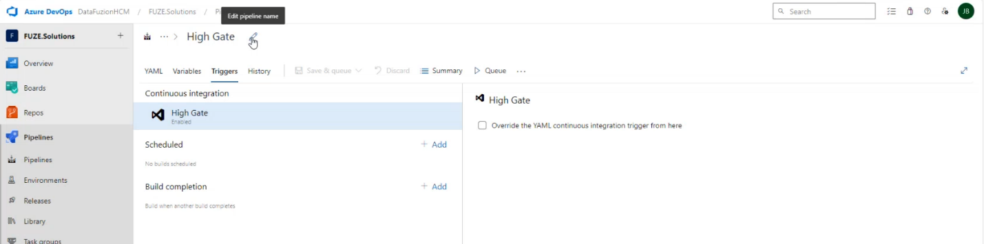

* 1. Edit the name to {Project name} -CI. Click on a checkbox "Override the YMAL continuous…. "

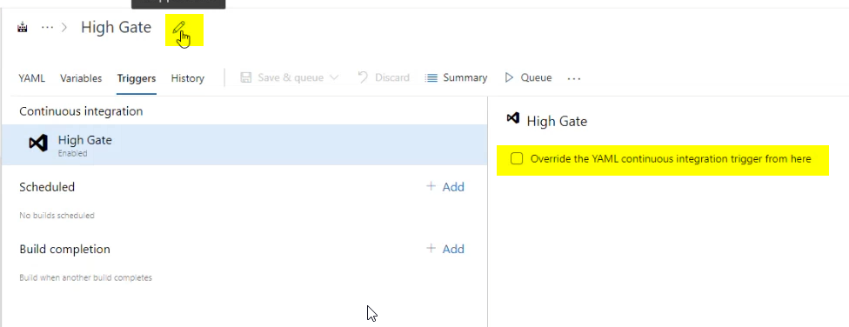

* 1. Make sure "Enable Continuous integration" is selected

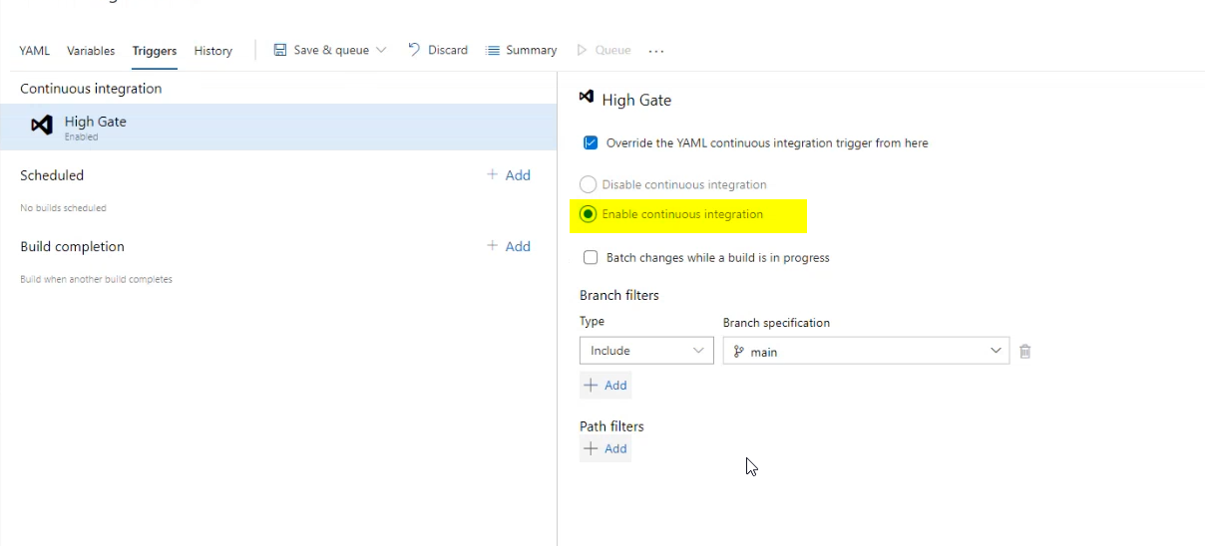

* 1. Click on "Save"

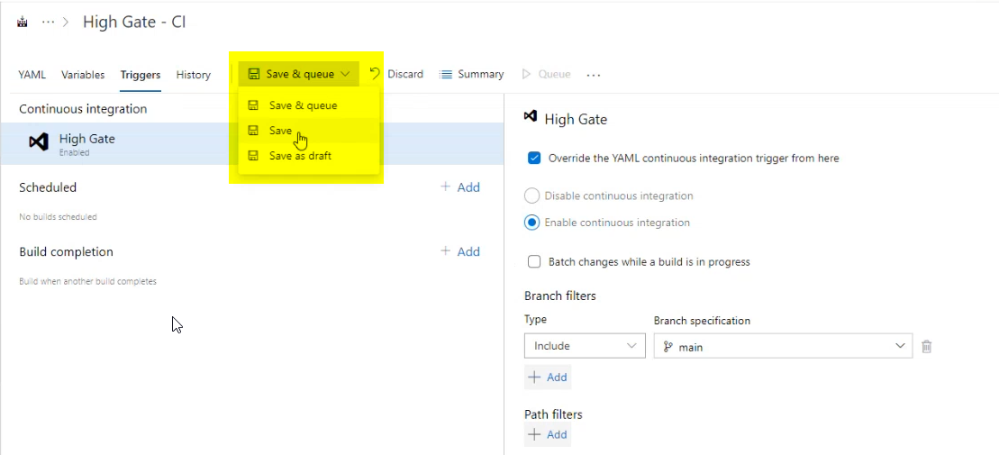

* 1. In popup add comment

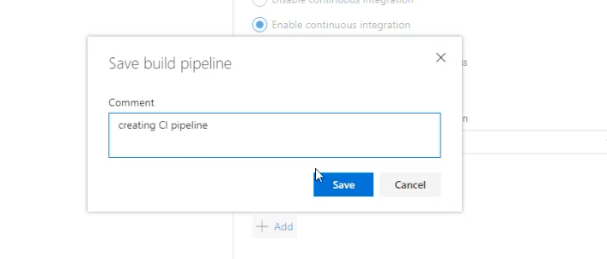

**CD Pipeline**

* 1. Click on "New Pipeline" button from top



* 1. Click on "Azure Repos Git"



* 1. Click on "Azure Repos Git"
  2. Select your project's repo



* 1. Select "Existing Azure Pipelines YMAL file



* 1. Select /deploy.yml file. Click on Continue.

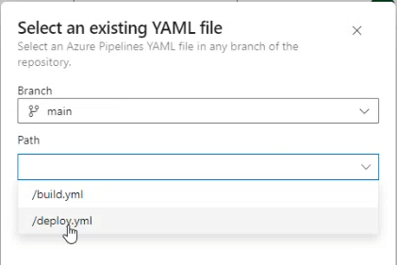



* 1. Click on dropdown icon with Run and click on Save.



* 1. Once it is saved, below screen will appear.



* 1. Click on "Edit" from top
  2. Click on a three dot icon > Triggers



* 1. It opens the screens as below



* 1. Edit the name to {Project name} -CD. Click on a checkbox "Override the YMAL continuous…. "



* 1. Click on "Disable continuous integration"

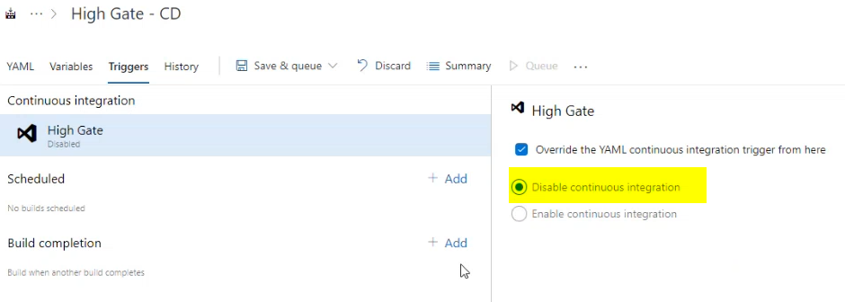

* 1. Click on Add button after the Build completion

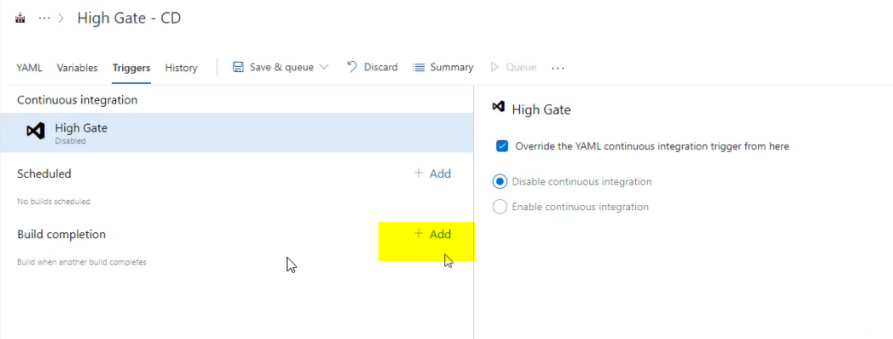

* 1. It opens the window for CI on other side. Select Trigger build as " Project name - CI".
  2. On Trigger Build > Select Project name - CI
  3. Click on Save button
  4. 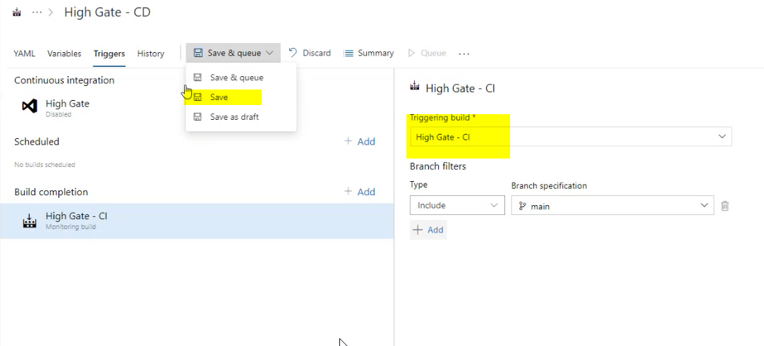
  5. Add Comment and click on save

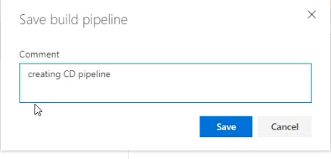

* 1. Change small thing in code
  2. Push changes
  3. Check CD and CI pipeline run on code.